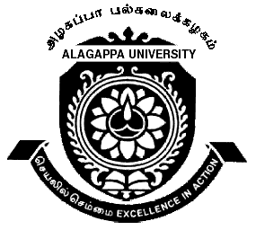ALAGAPPA UNIVERSITY

(Accredited with ‘A’ Grade by NAAC)
Karaikudi - 630 003
SCHOOL OF CHEMISTRY
Department of Industrial Chemistry
(DST FIST and UGC SAP Assisted Department)

WALK-IN INTERVIEW

Eligible candidates may appear for the Walk-in Interview for the selection of Three Research Fellows in the Alagappa University Research Funded (AURF) projects of this Department;

AURF FUNDED PROJECT | PROJECT 1 | PROJECT 2 | PROJECT 3
Project Title | Study of silver nano particle for functionality in textile materials | Studies on the effect of Eco-friendly materials in Textiles | Fluorescence Biosensor based on insoluble β-cyclodextrin polymer for direct determination of cholesterol and 2,4- and 2,6-dinitrophenols
Principal Investigator | Dr.H.Gurumallesh Prabu, Professor | Dr. M.Sundrarajan,  Assistant Professor | Dr. T. Stalin,  Assistant Professor
No. of Project Fellows required | 1 (One) | 1 (One) | 1 (One)

Fellowship duration : 8 months

Stipend : Rs. 5,000/-pm (Consolidated)

Essential qualification : M.Sc., in Chemistry/ Industrial Chemistry/ Applied Chemistry with minimum of 55% marks
Desirable qualification The candidates with UGC/CSIR/NET/GATE qualification will be preferred.
Research experience in respective fields is desirable.

Interested Candidates are requested to appear with original and attested copies of the relevant certificates for the Interview in the Department of Industrial Chemistry, Alagappa University, Karaikudi on 02.02.2010 at 11.00 am.

Dr.P.Manisankar
Professor and Head
Department of Industrial Chemistry
School of Chemistry
Alagappa University
Karaikudi-630 003
Place: Karaikudi
Date: 20.01.2010

Note: No TA/DA is permissible for attending the interview.

